Local Dev Environment Setup

Author: Bogdan Pshonyak (bpshonyak@mail.greenriver.edu)

1. Download MAMP

<https://www.mamp.info/en/>

1. Open the MAMP Program. A UI similar to the one below will appear.

**Mac**  **Windows**

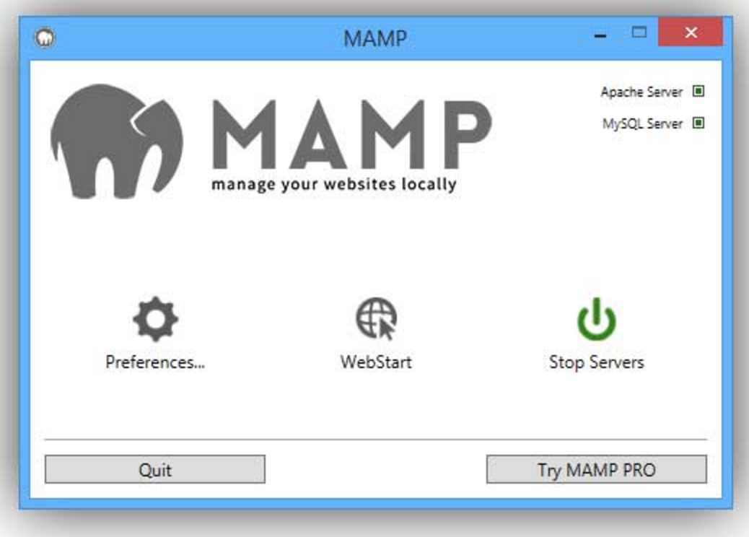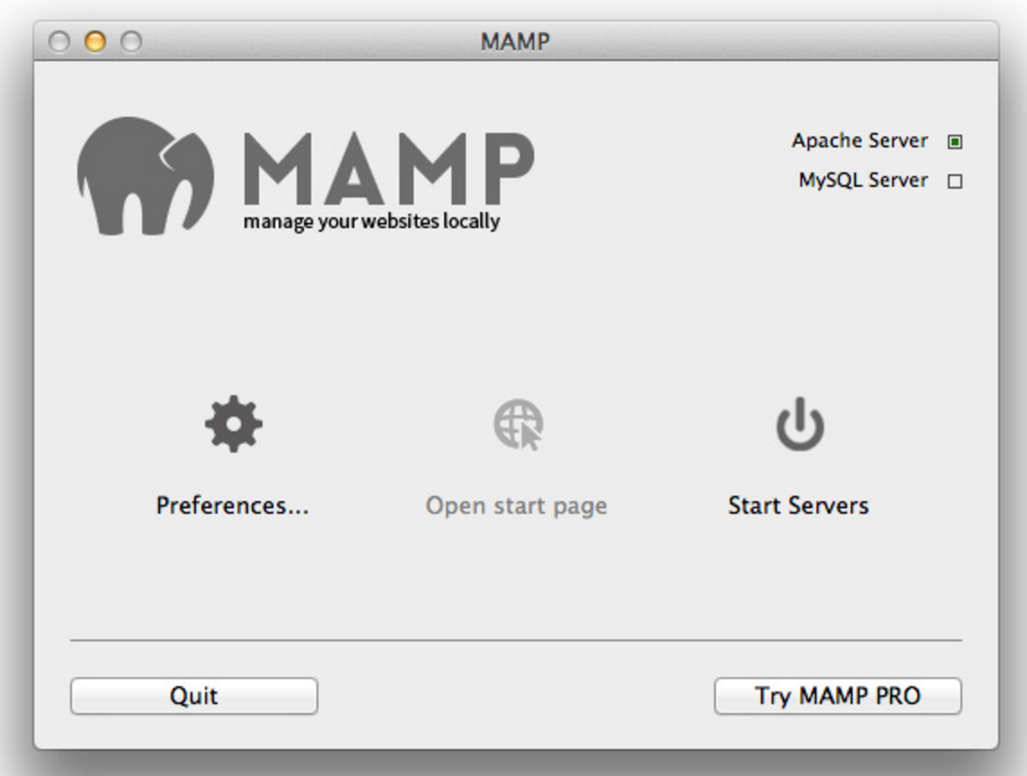

1. Click **Preferences…** then **Web Server**. Change the **Document Root** to the the **itconnect** folder (ITConnect repo folder). Then press **OK**. ***Clone the ITConnect Github repo to get the necessary files***

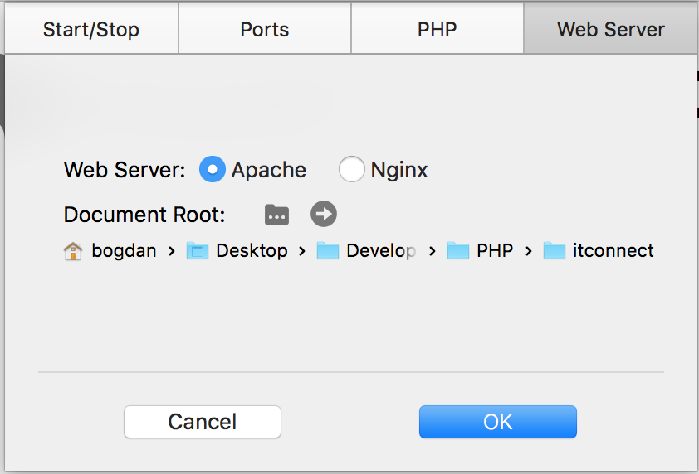

1. Press **Start Servers**, then press **Open WebStart page**. A webpage similar to the one below will appear.

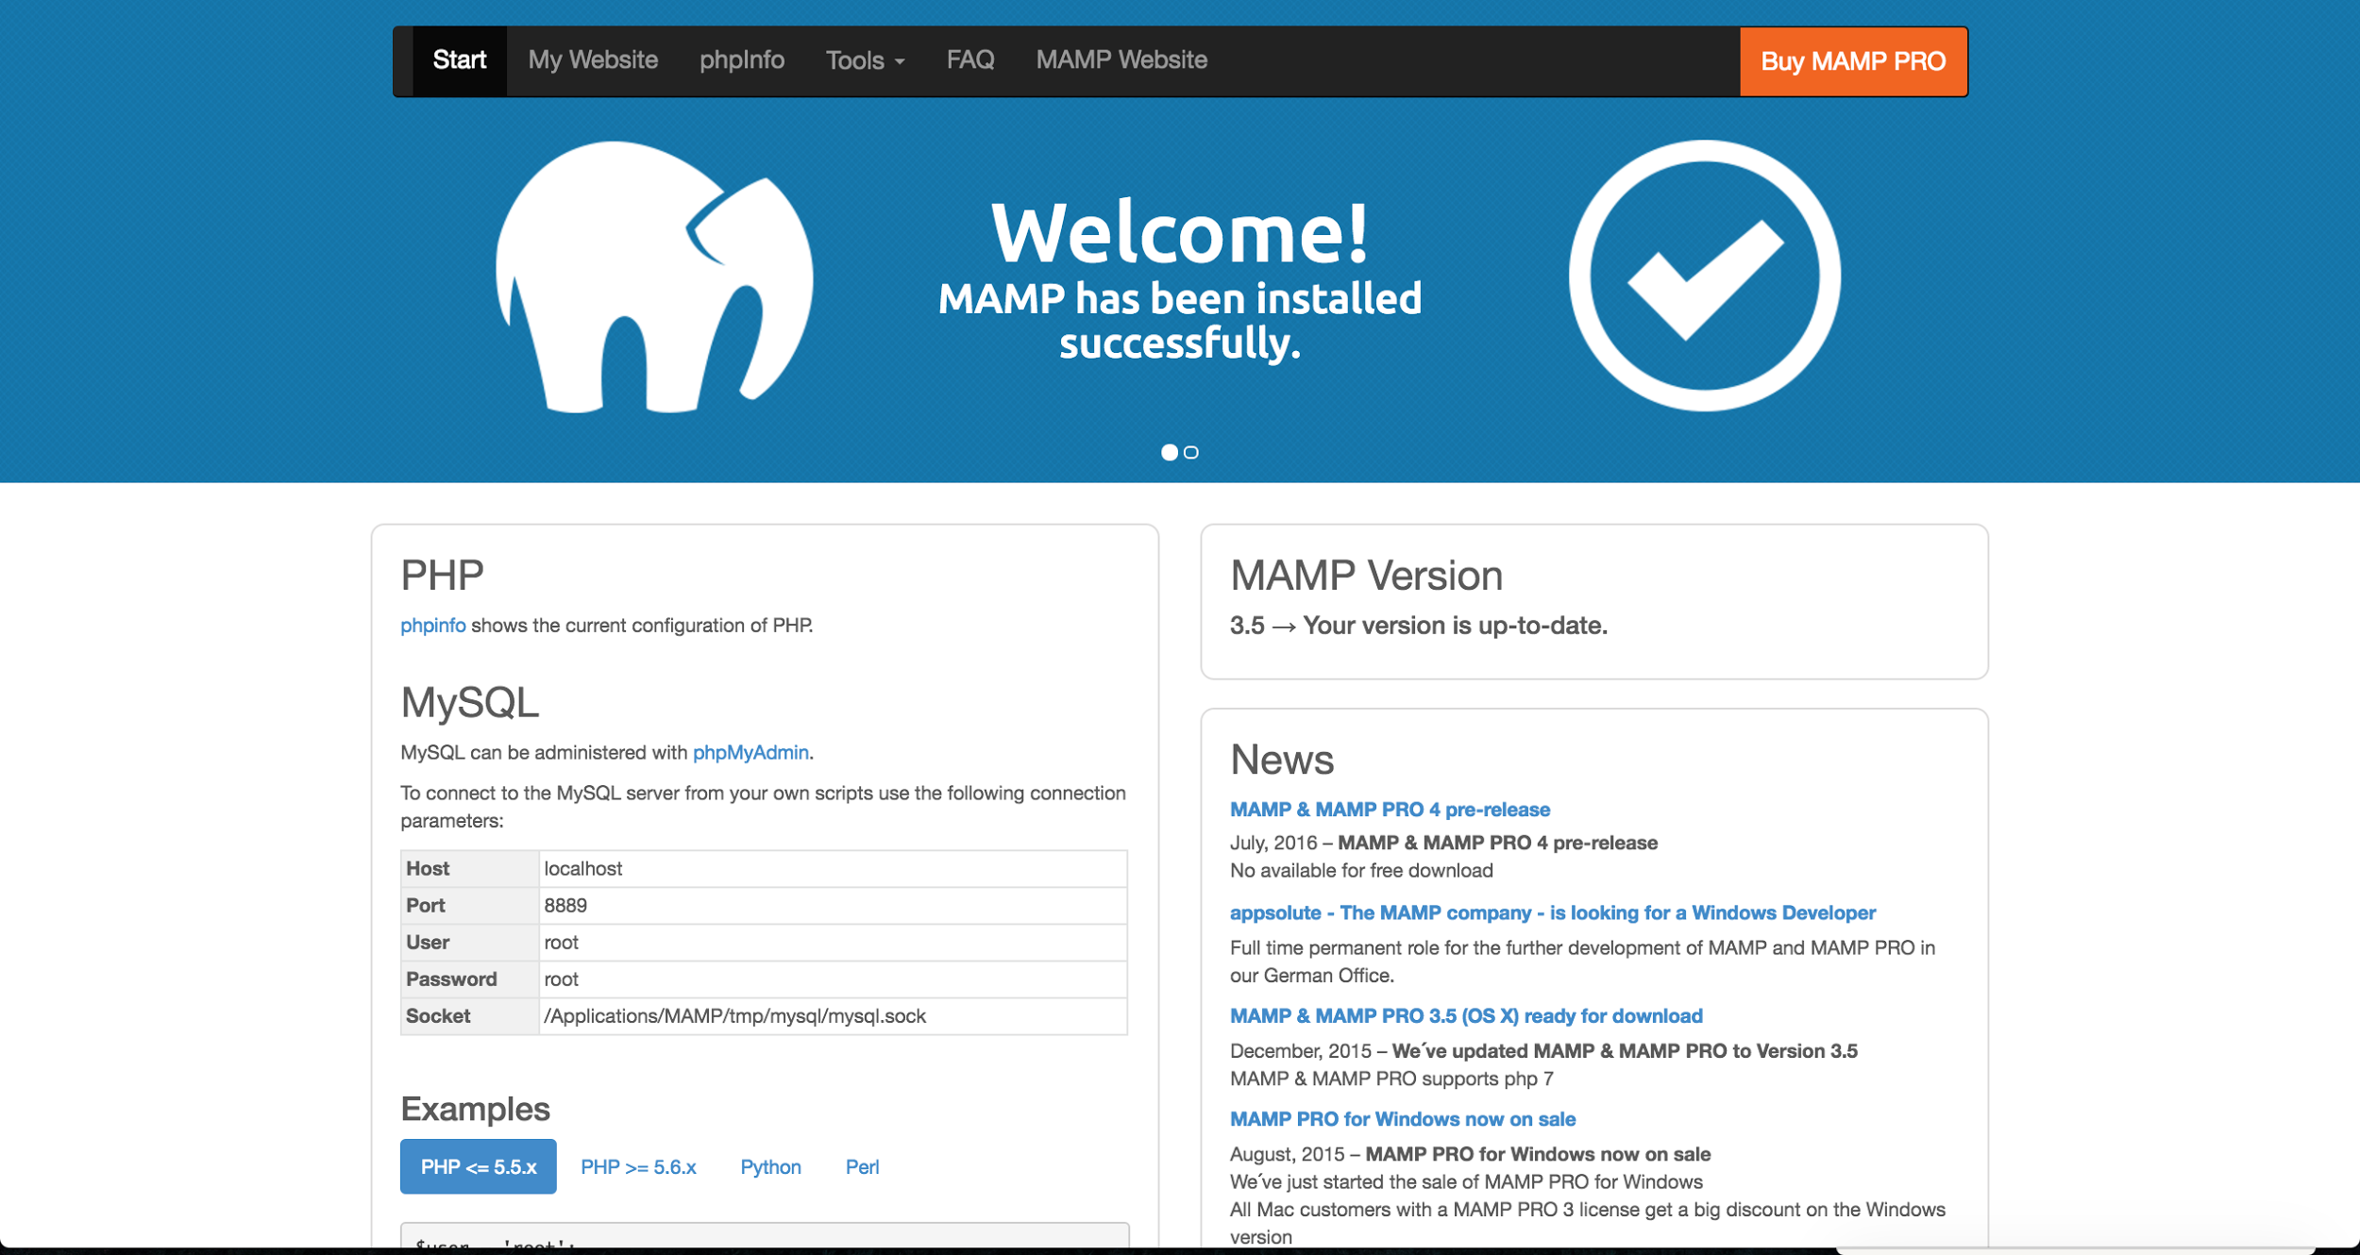

1. In the navigation bar, click **Tools**, then **phpMyAdmin**. A webpage similar to the one below will appear.

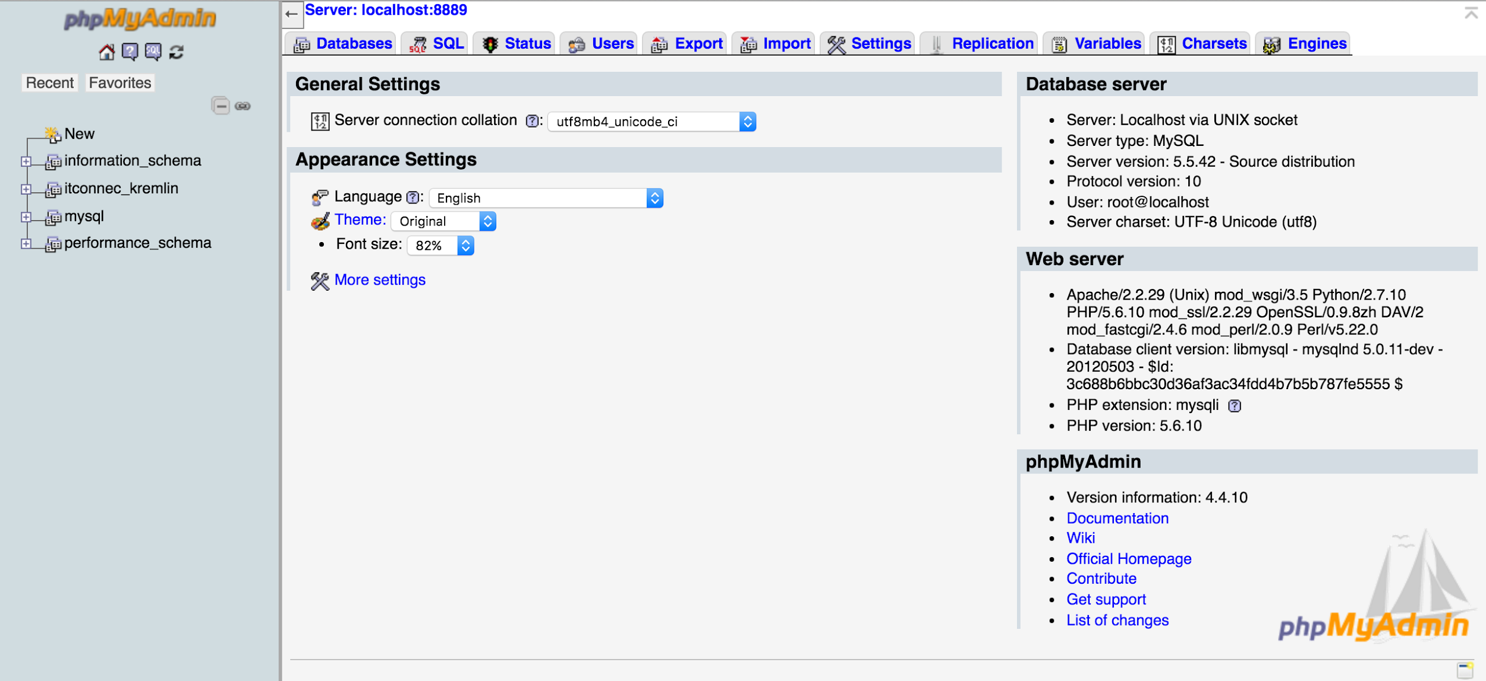

1. Click **Databases**. Under the label **Create database**, type **itconnec_kremlin** into the **Database Name** field. Click **Create**.

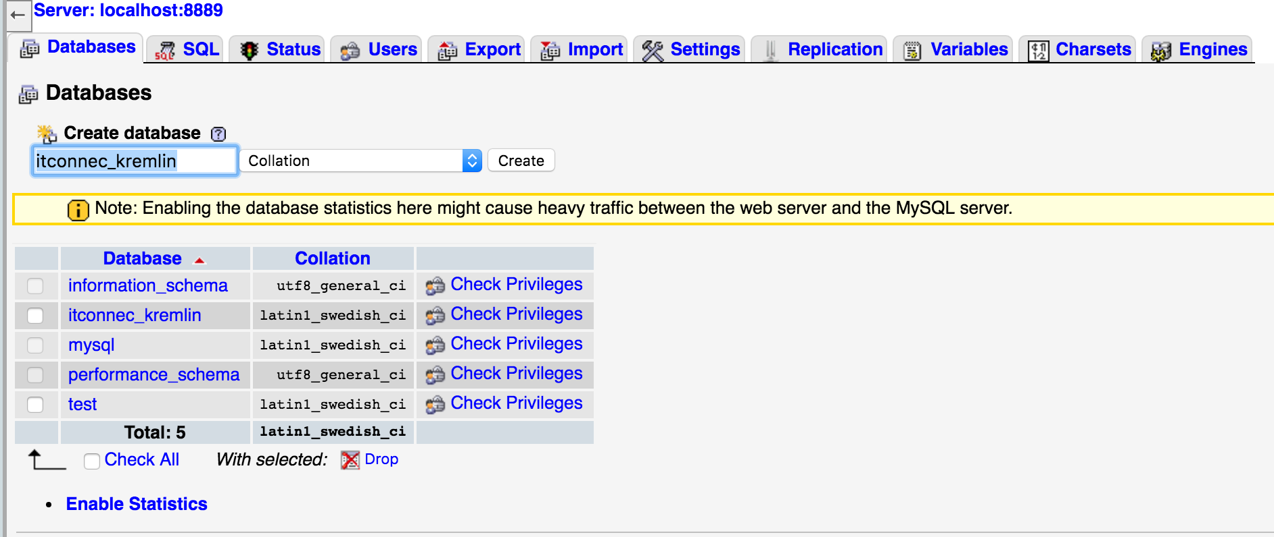

1. You should now be in your local **itconnec_kremlin** database. Click **Privileges** and then **Add user**.

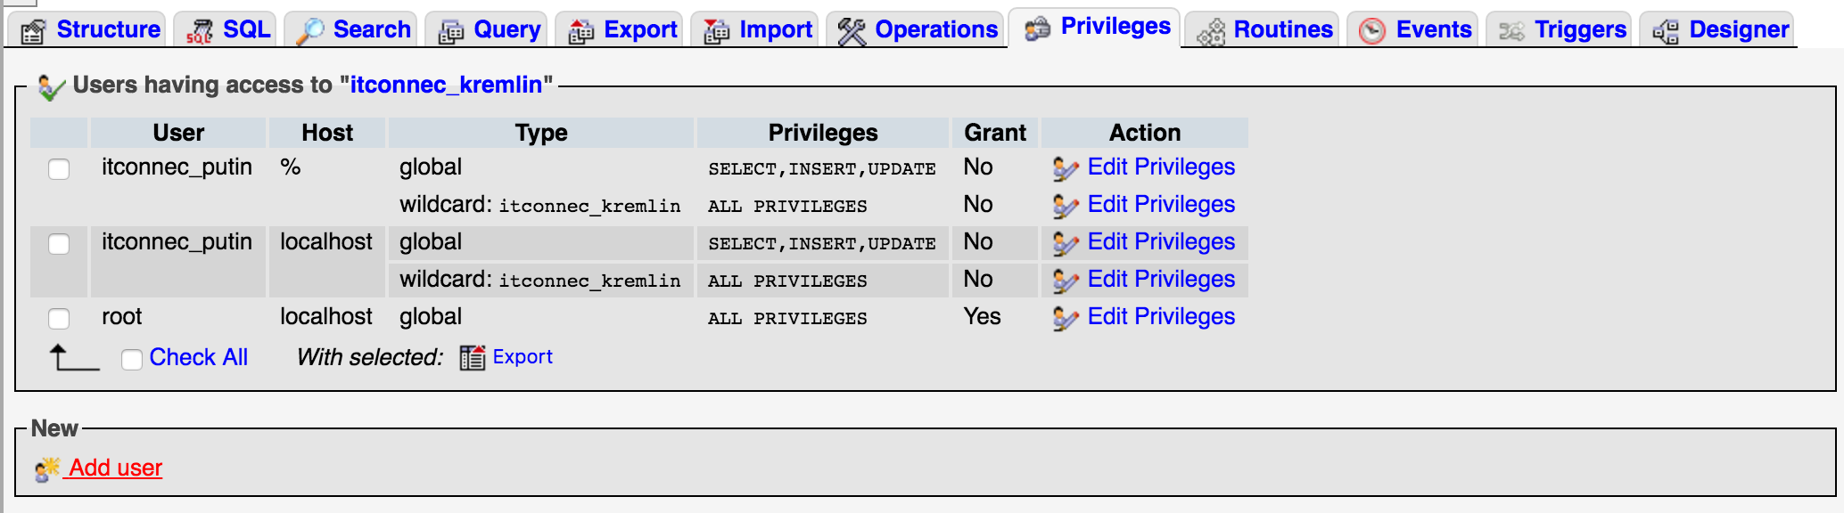

1. Type **itconnec_putin** for the **User name**, select **Local** for **Host** and type **boggybogbogz123!** for the **Password**. Scroll down to the bottom of the page and press **Go**.

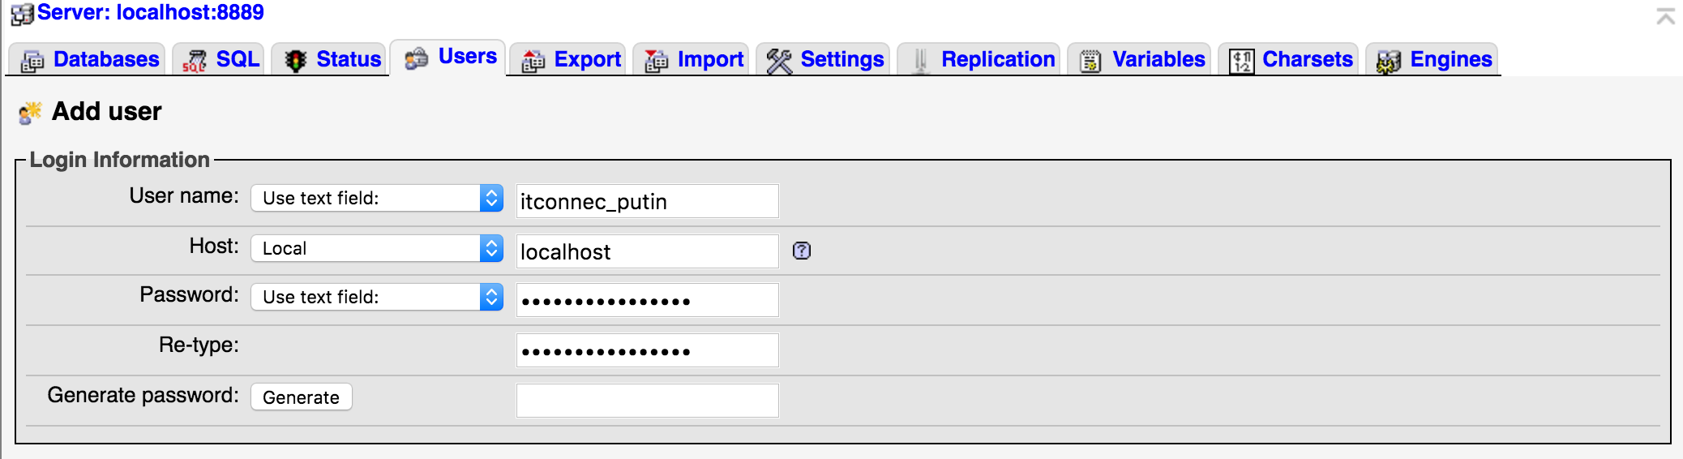

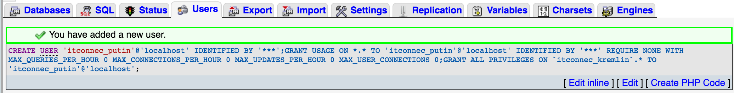

1. Click on the **SQL** tab. In the **ITConnect repo**, there is a **db** folder that contains a file called **database_code.sql**. The contents look similar to the code below. ***These are the SQL statement needed to populate the local database.***

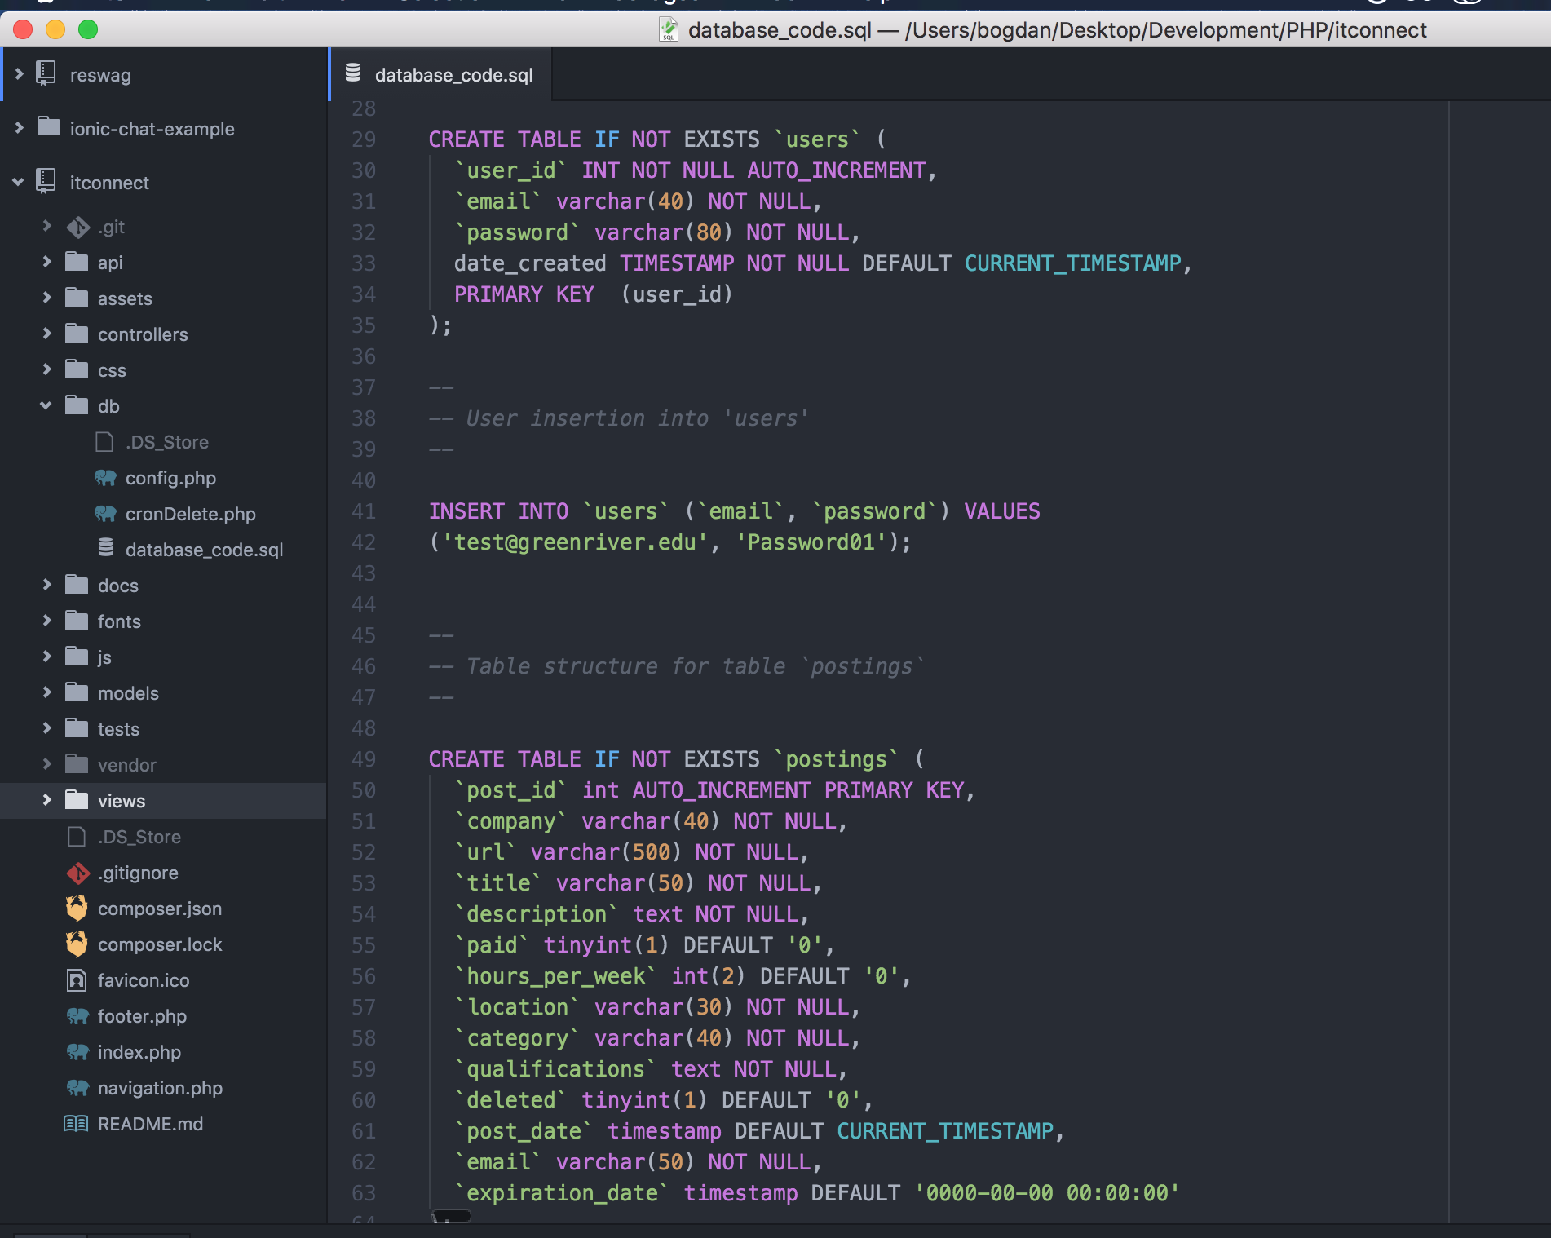

1. Copy each statement block into the phpMyAdmin SQL field and execute them. After you are done, your local database is all setup!

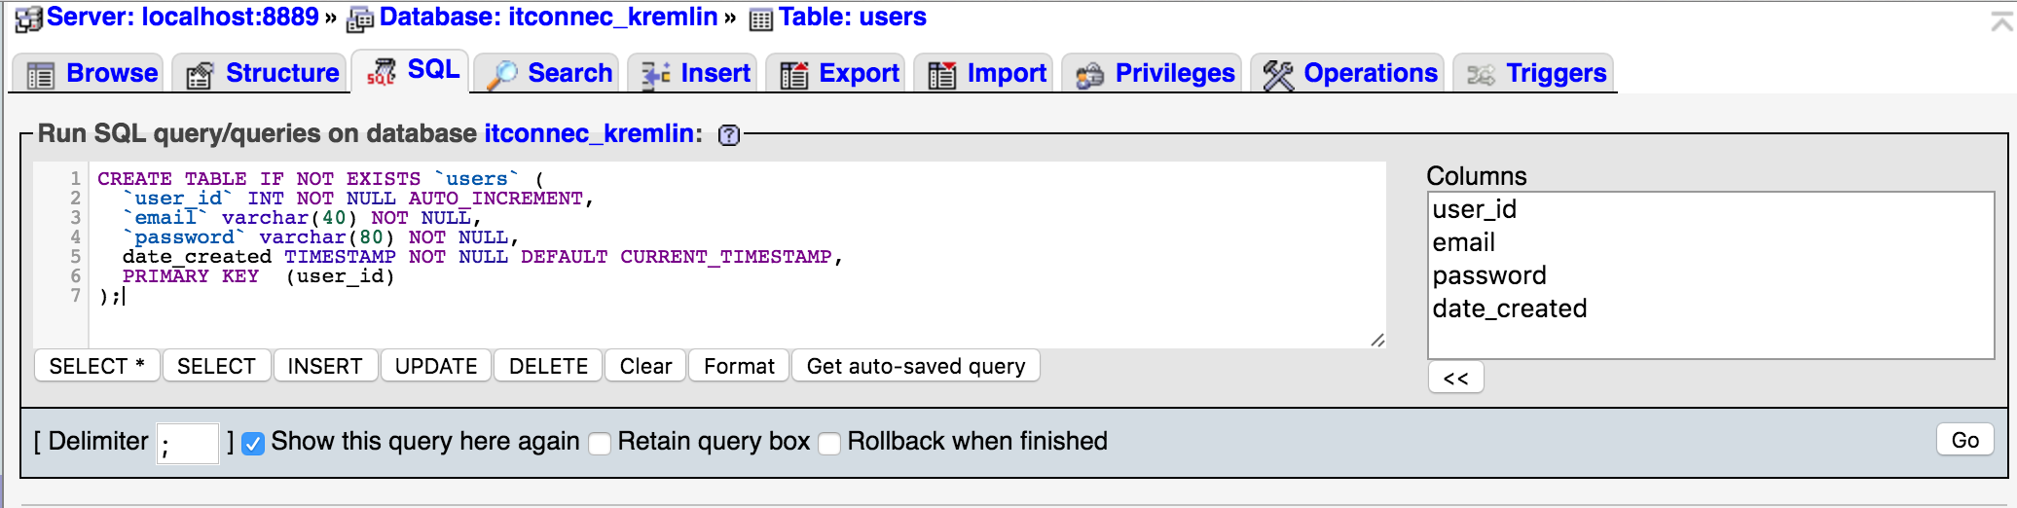

1. Navigate to <http://localhost:8888/> and your local ITConnect website should be up and running! ***The default admin user created is test@greenriver.edu with a password of Password01***